**Deploying Flask App on EC2 Instance**

1. Create an EC2 Instance
2. Make changes in security groups. Click on security groups, select edit inbound rules.

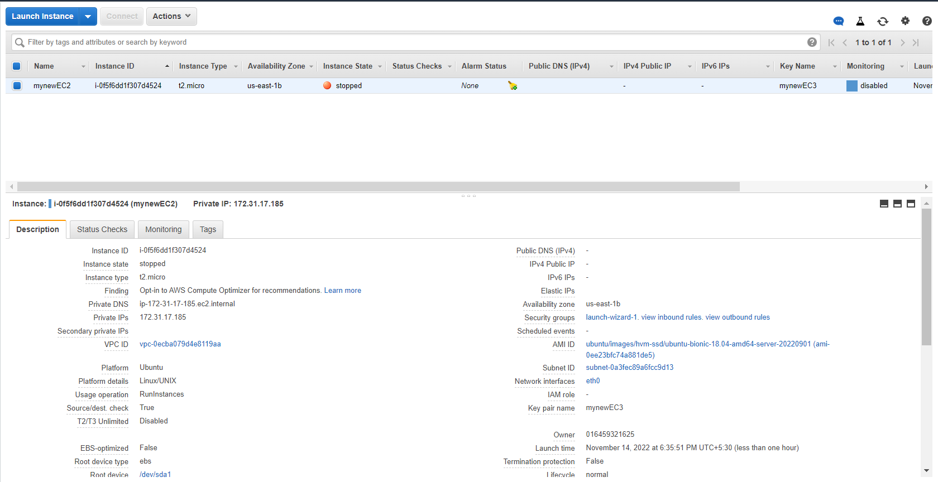

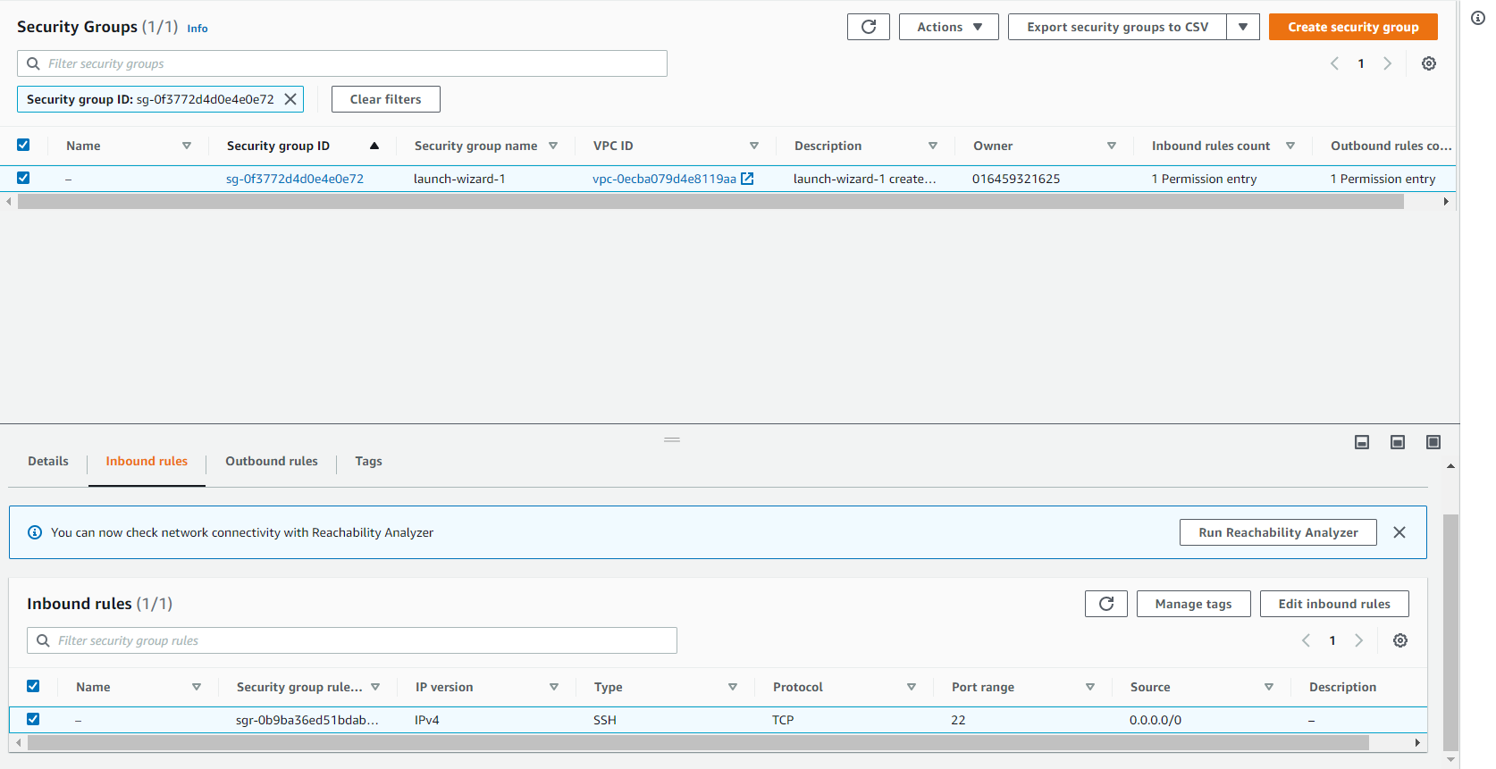

1. Make changes for Network Ports to enable HTTP Port and Custom Port for flask app.py file. Save Changes.

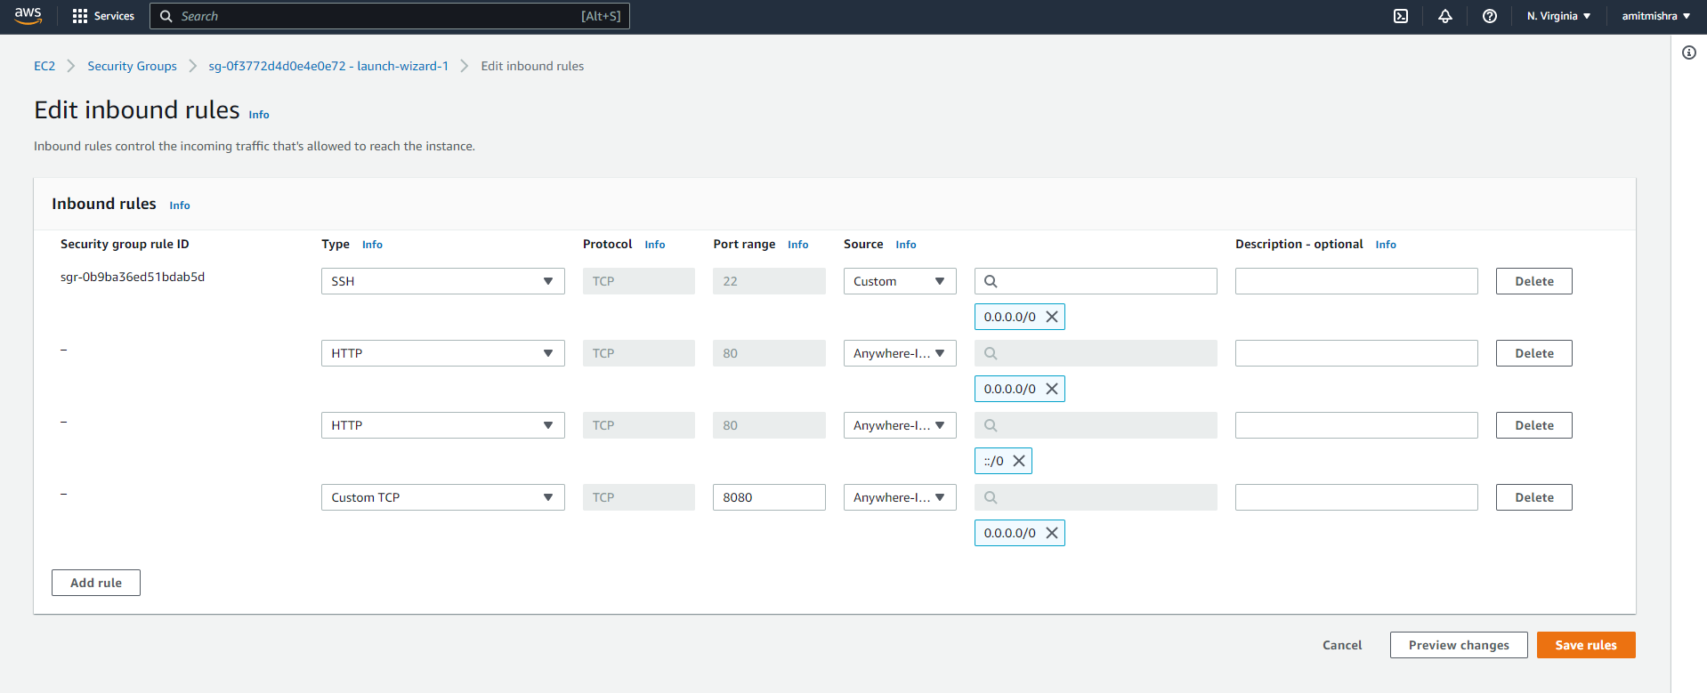

1. Start EC2 Instance and connect using Putty.
2. Install requirements for Flask, MongoDB in EC2 Instance.

* sudo apt-get update
* sudo apt-get install python3-pip
* pip3 install flask

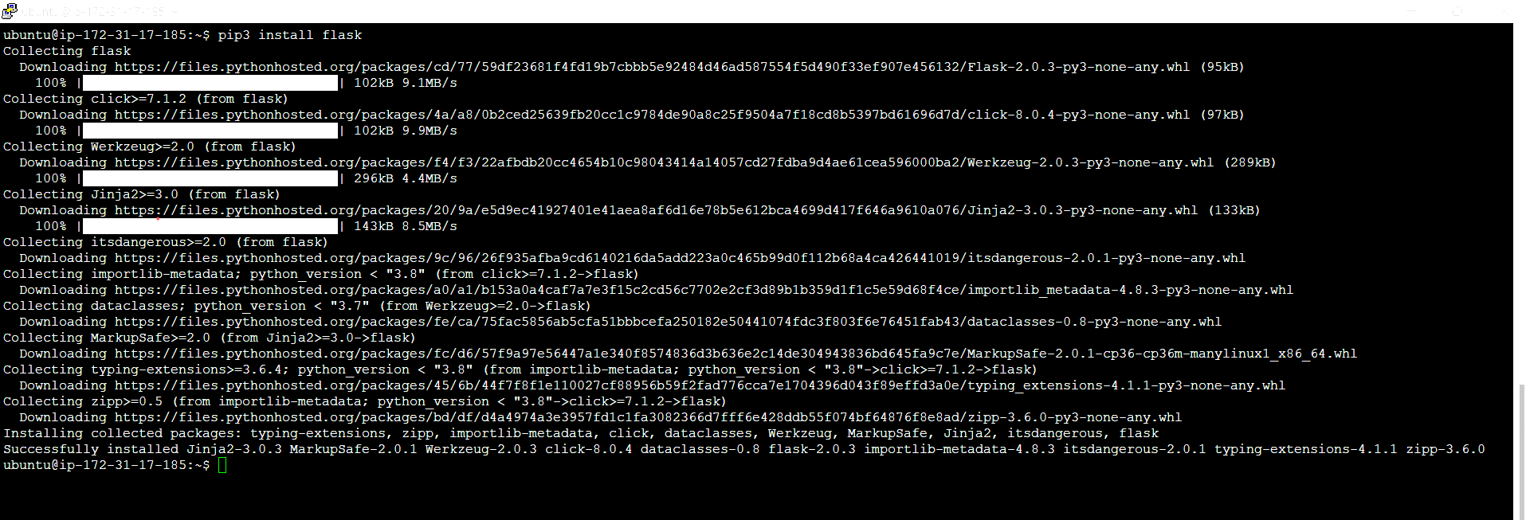

* pip3 install pymongo

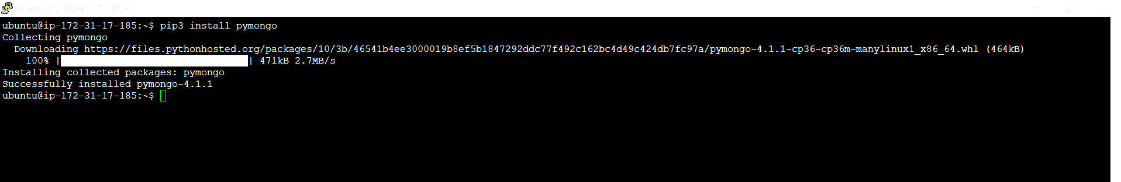

1. Install Docker on Ubuntu EC2 Instance.

<https://docs.docker.com/engine/install/ubuntu/>

* + sudo apt-get remove docker docker-engine docker.io containerd runc
  + sudo apt-get update
  + sudo apt-get install ca-certificates curl gnupg lsb-release
  + sudo mkdir -p /etc/apt/keyrings
  + curl -fsSL https://download.docker.com/linux/ubuntu/gpg | sudo gpg --dearmor -o /etc/apt/keyrings/docker.gpg

echo \

"deb [arch=$(dpkg --print-architecture) signed-by=/etc/apt/keyrings/docker.gpg] https://download.docker.com/linux/ubuntu \

$(lsb_release -cs) stable" | sudo tee /etc/apt/sources.list.d/docker.list > /dev/null

* + sudo apt-get update
  + sudo apt-get install docker-ce docker-ce-cli containerd.io docker-compose-plugin
  + sudo docker run hello-world

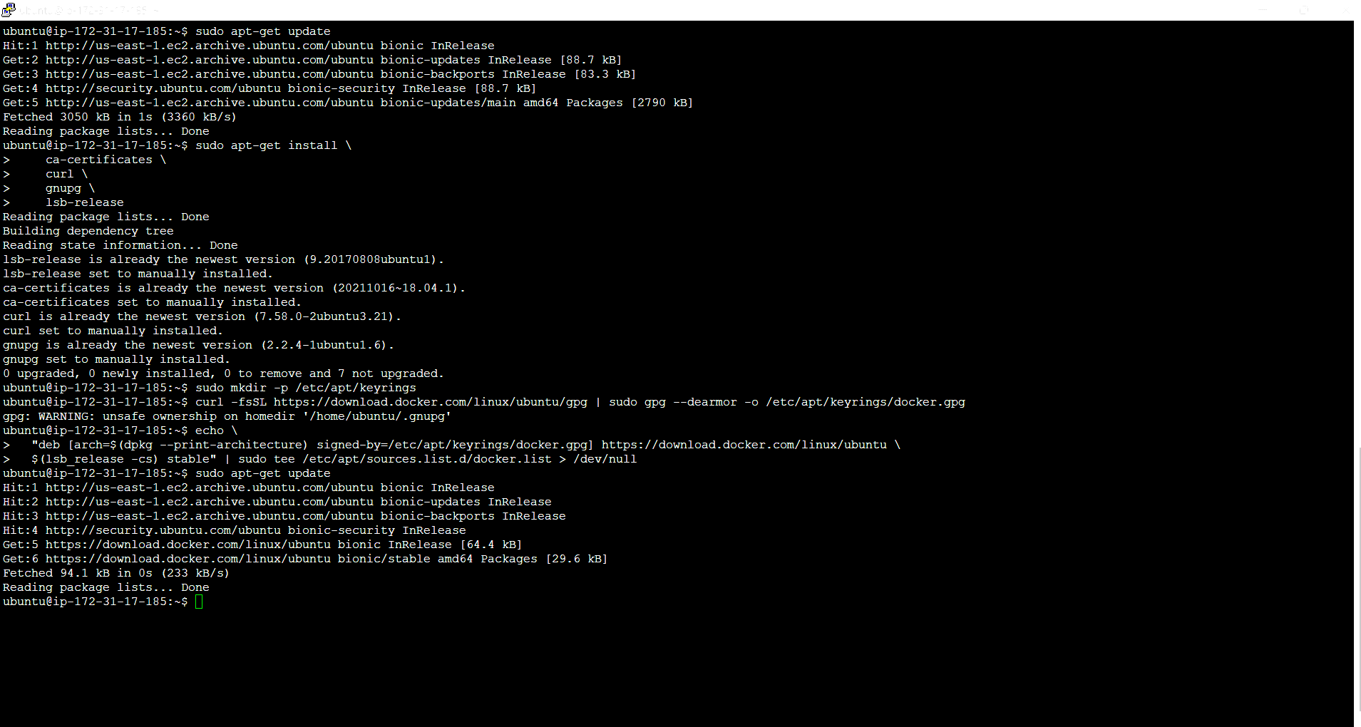

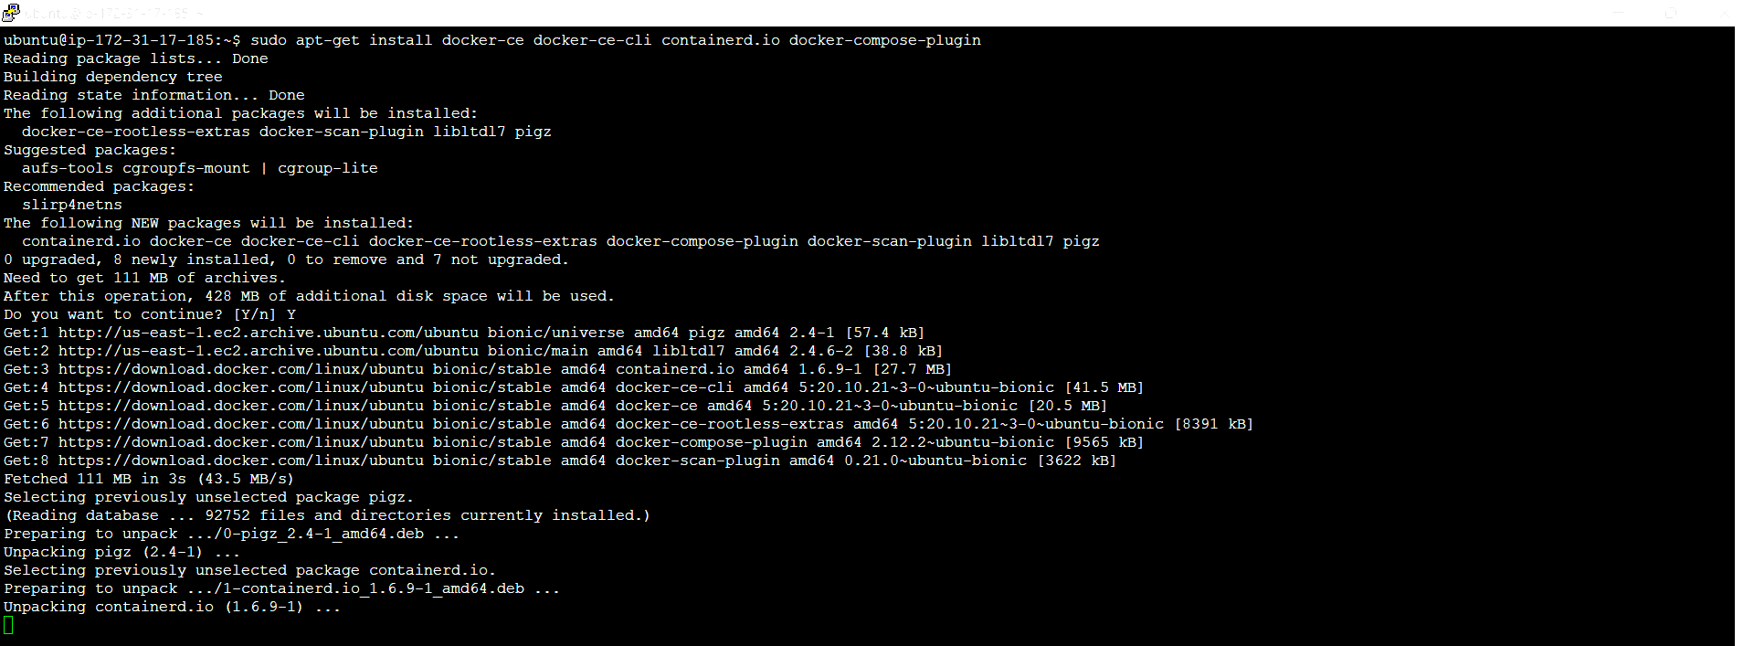

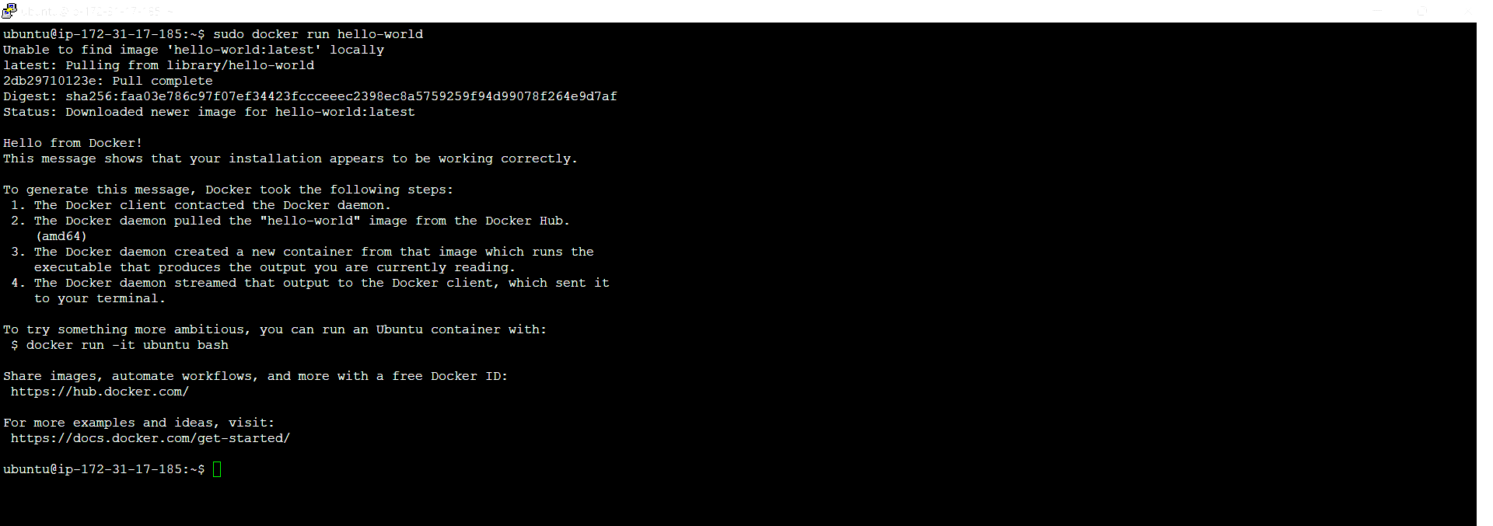

1. Install webserver nginx and gunicorn3

* sudo apt-get install nginx
* sudo apt-get install gunicorn3

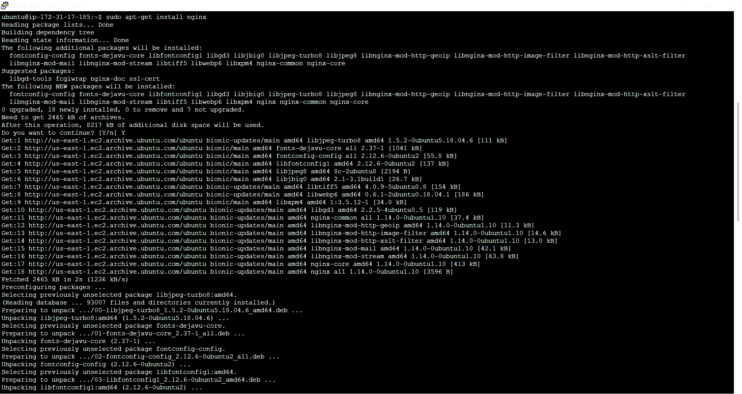

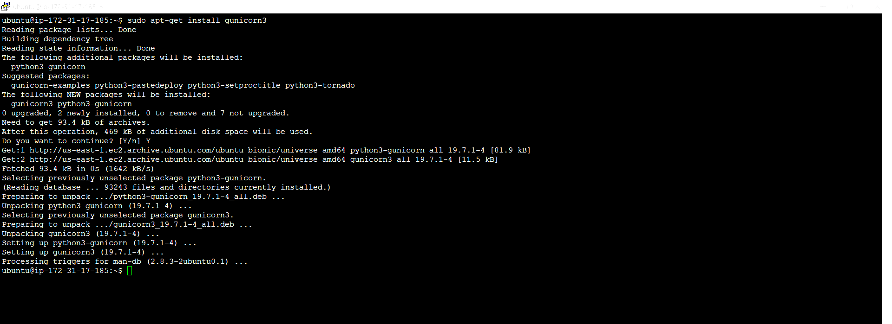

1. Run docker Commands
   * sudo docker version

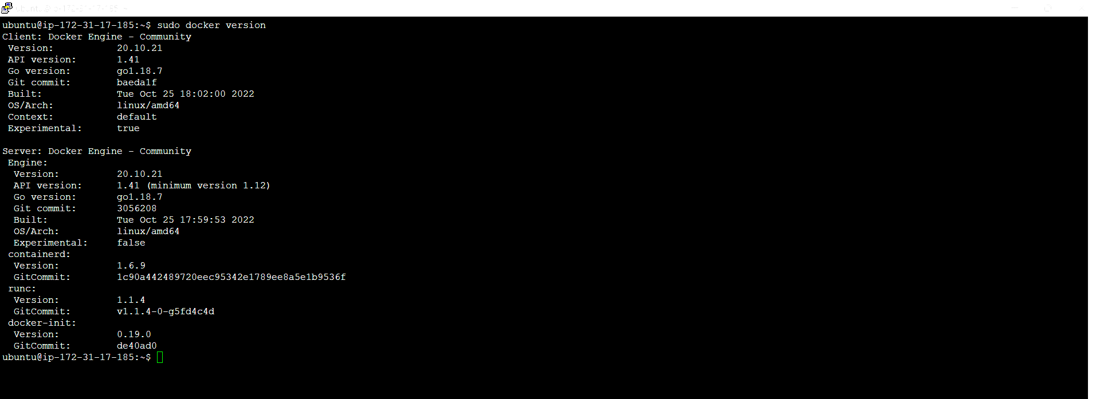

* sudo docker images
* sudo docker ps
* sudo docker pull mongo

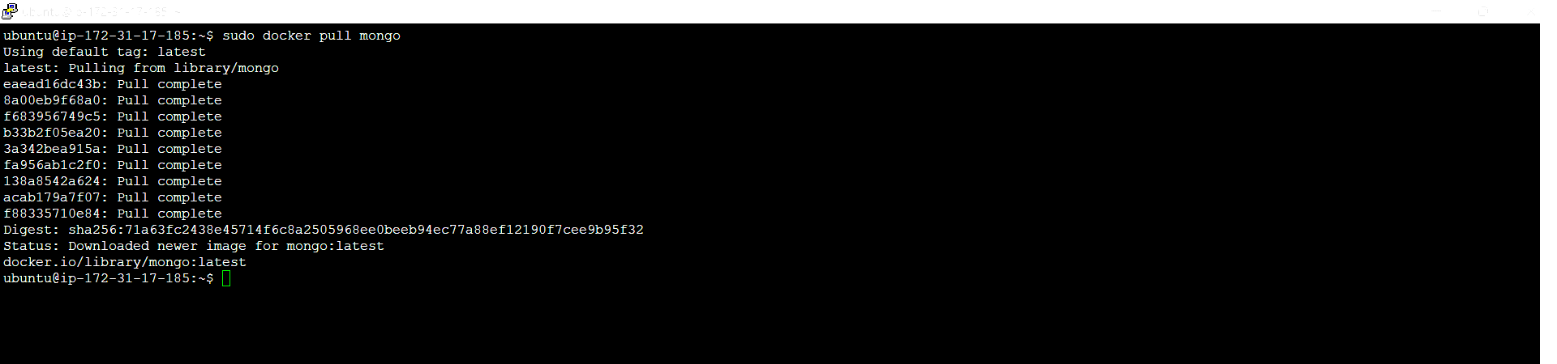

* sudo docker pull mongo-express

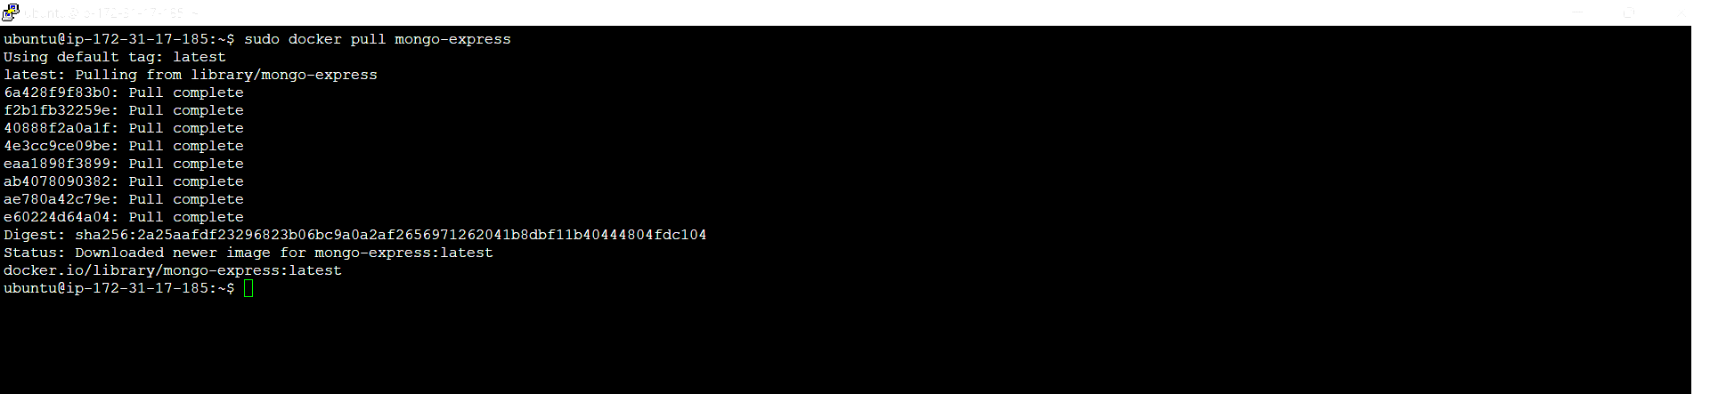

* sudo docker network ls

Create a Mongo Network

* sudo docker network create mongo-network

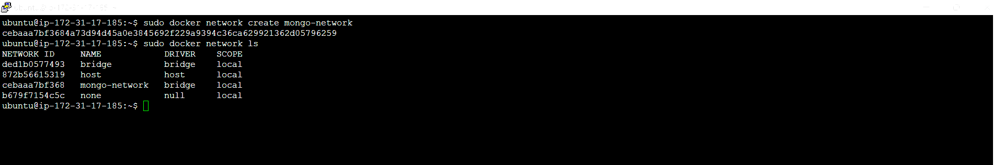

* sudo docker run -d --network mongo-network --name mongodb -p 27017:27017 -e MONGO_INITDB_ROOT_USERNAME=admin -e MONGO_INITDB_ROOT_PASSWORD=password mongo

Use this to check logs status of mongodb.

* sudo docker logs <log id>

**Run mongo-express**

* sudo docker run -d -p 8081:8081 -e ME_CONFIG_MONGODB_ADMINUSERNAME=admin -e ME_CONFIG_MONGODB_ADMINPASSWORD=password --net mongo-network --name mongo-express -e ME_CONFIG_MONGODB_SERVER=mongodb mongo-express

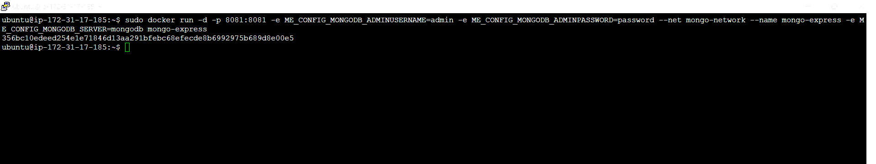

Use this to check logs status of mongo express. Command will show IP & Port Number

* sudo docker logs <log id>

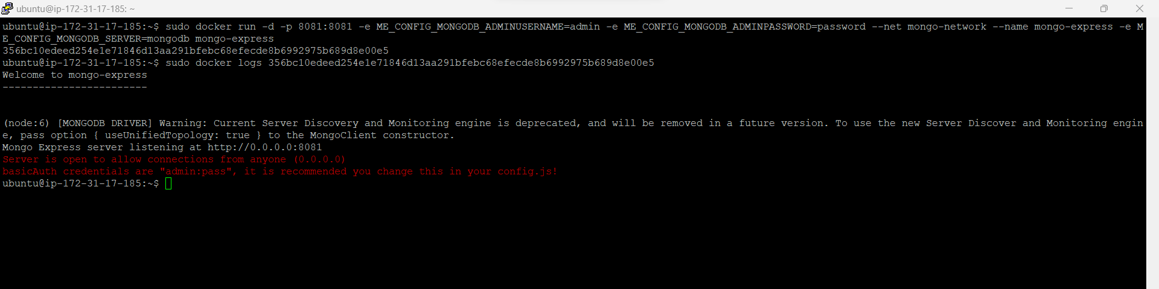

* As mongo-express is running on TCP port number 8081 We have to add a new inbound rule. Save Changes.

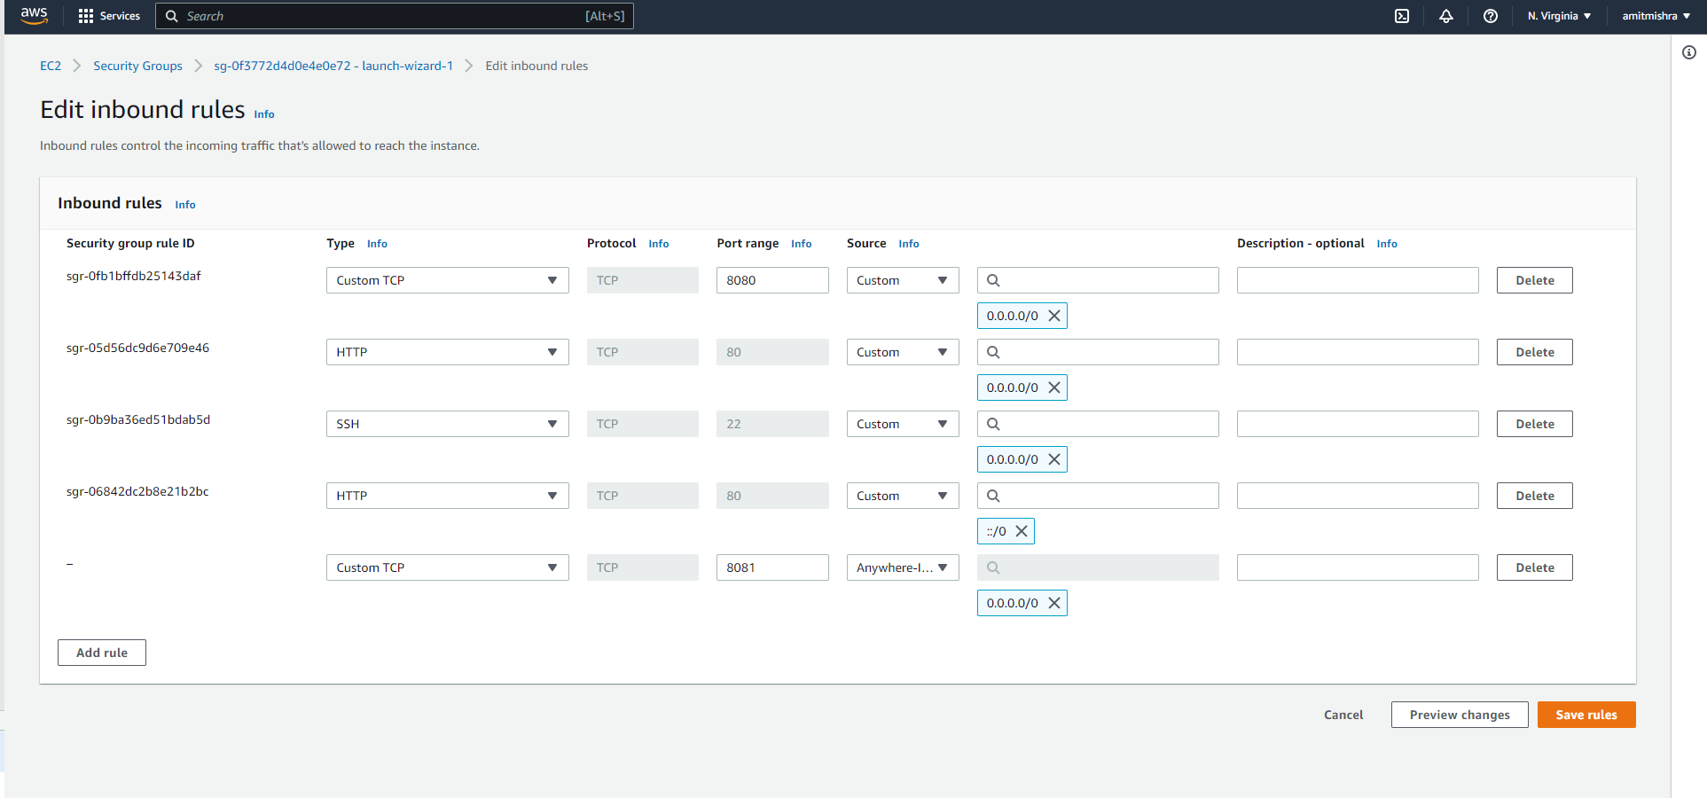

* Open browser and type public IP address. Port number 8081 e.g. 54.242.115.213:8081

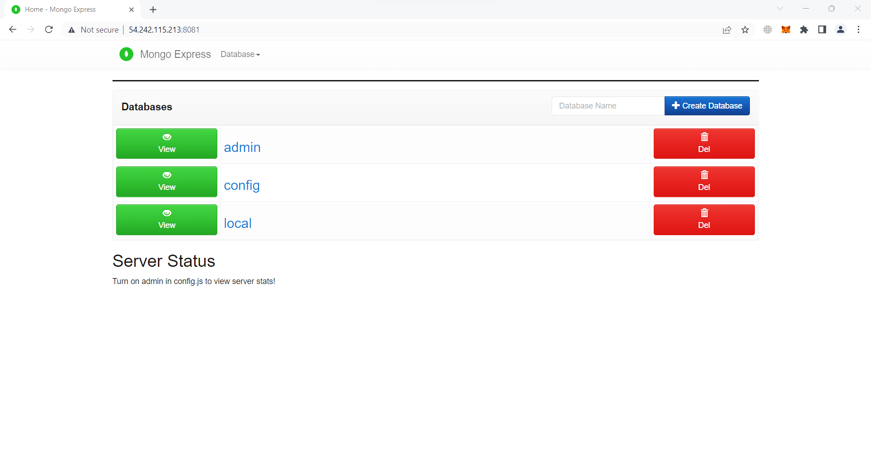

* Create a Program Folder **FLASK_MONGO**

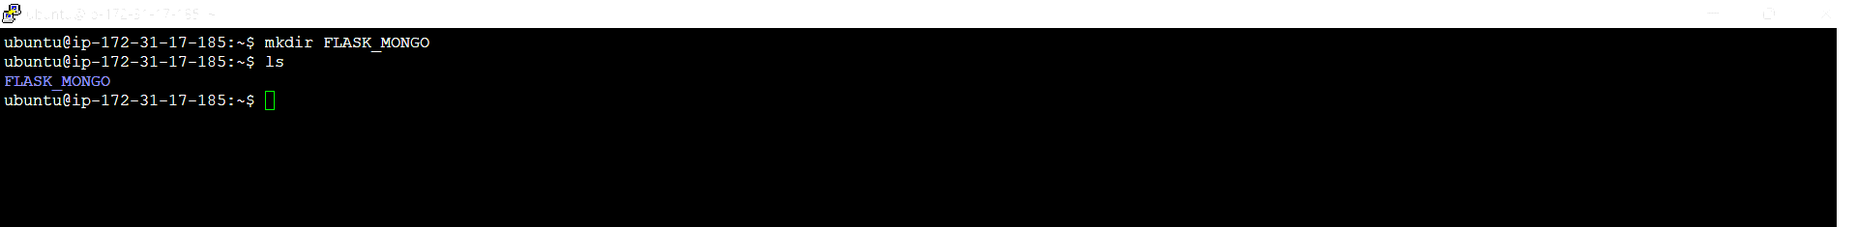

* Create a Program File.
* cd FLASK_MONGO.
* nano app.py

Write the Flask Code in this.

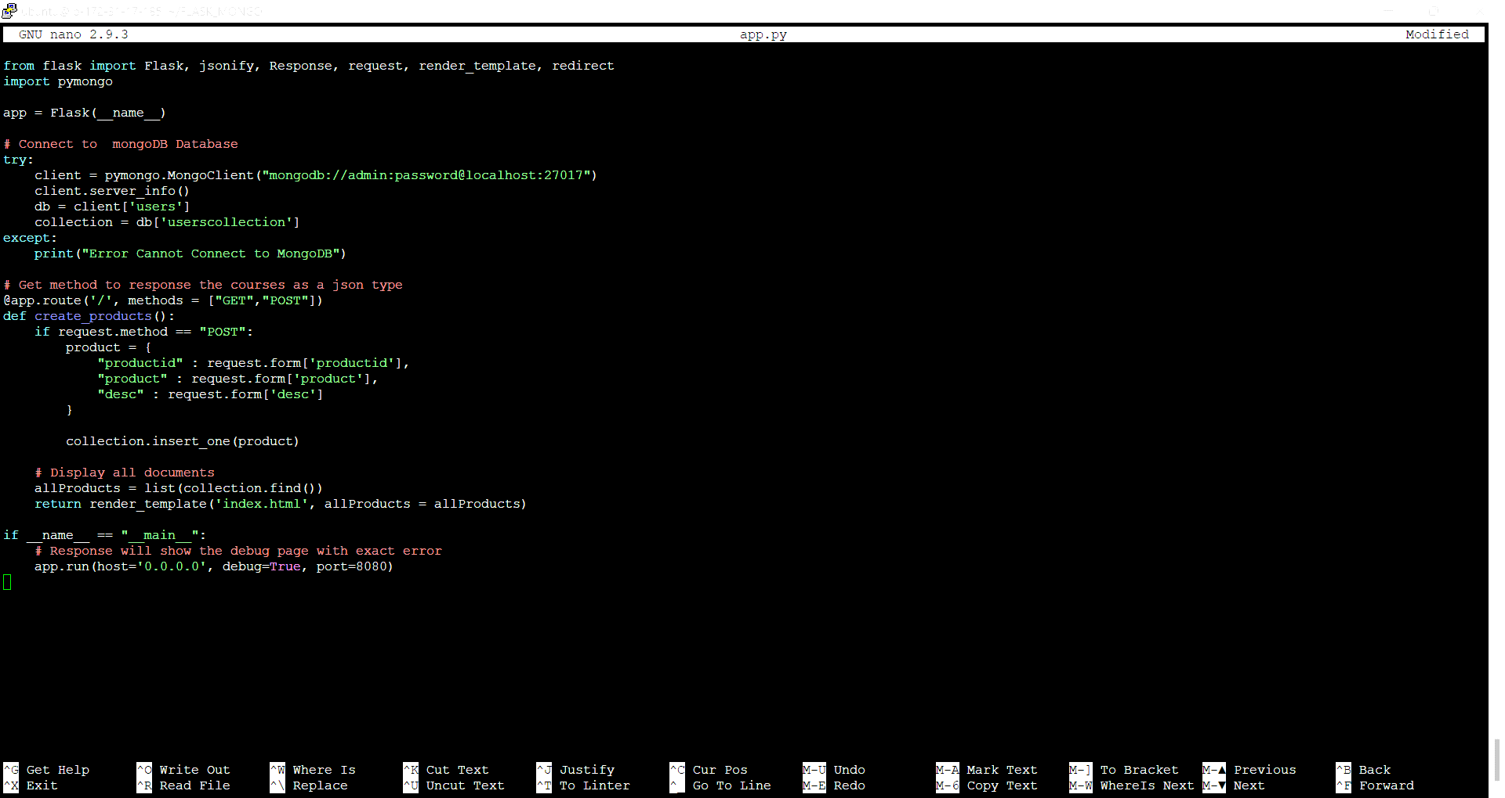

* Make Directory “templates” . Create a HTML File. Write the code and save changes.

